Background
The Hodgkin-Huxley model represents the first comprehensive effort to integrate physiology and mathematics to model action potentials using a system of four ordinary differential equations (ODEs) to simulate the evolution of voltage and ionic exchange at the cell membrane over time (Hodgkin and Huxley, 1952). In this report, the Hodgkin-Huxley model is briefly detailed and implemented in both MATLAB and Python.
Methods
Mathematical Approach
A system of ODEs was solved numerically to represent the derivatives of voltage and gating probabilities (n, m, h) with respect to time, creating a simulation of action potentials. The equation for the derivative of voltage with respect to time was:
$$\frac{dV}{dt}=\frac{1}{C_{m}}·[I_{stim}-I_{Na}-I_{K}-I_{leak}]$$
where C_{m} is the membrane capacitance, I_{stim} is the stimulus current (amplitude of the injected stimulus), I_{Na} is the depolarizing sodium current, I_{K} is the repolarizing potassium current, and I_{leak} is the current that represents ionic leakage from other ions such as chloride. These currents were calculated using the following formulas:
$$I_{Na}=g_{Na}m^{3}h\left(V-E_{Na}\right)$$
$$I_{K}=g_{K}n^{4}\left(V-E_{K}\right)$$
$$I_{leak}=g_{leak}(V-E_{l})$$
Where g_{Na} is the conductance of sodium, m is the probability of the sodium channel activation gate being in a permissive state, h is the probability of the sodium channel inactivation gate being in a permissive state, V is the current voltage, E_{Na} is the equilibrium potential for sodium, g_{K} is the conductance of potassium, n is the probability of the potassium channel activation gate being in a permissive state , E_{K} is the equilibrium potential for potassium, gL is the conductance of any additional ionic leakage and E_{L} is the corresponding equilibrium potential.
The derivatives of m, h, and n with respect to time are also used to provide a more comprehensive picture of ion exchange across the cell membrane and are represented by the following equations:
$$\frac{dn}{dt}=α_{n}\left(V\right)\left(1-n\right)- β_{n}\left(V\right)n$$
$$\frac{dm}{dt}=α_{m}\left(V\right)\left(1-m\right)- β_{m}\left(V\right)m$$
$$\frac{dh}{dt}=α_{h}\left(V\right)\left(1-h\right)- β_{h}\left(V\right)h$$
Where α and β variables represent the rate constants for each gate. Put simply, these values describe the rate of permissiveness for ion exchange for all gates and were mathematically represented by the equations:

$$α_{n}=\frac{0.01\left(V+50\right)}{1-\exp{(\frac{-(V+50)}{10})}} ; β_{n}=0.125\exp{(\frac{-(V+60)}{80})}$$
$$α_{m}=\frac{0.1\left(V+35\right)}{1-\exp{(\frac{-(V+35)}{10})}} ; β_{m}=4.0\exp{(-0.0556(V+60))}$$
$$α_{h}=0.07\exp{(-0.05\left(V+60\right))} ; β_{h}=\frac{1}{1+\exp{(-0.1\left( V+30\right))}}$$
Consistent with the documentation from Siciliano (2012), the following parameters were used as constant values in the simulation for solving ODEs numerically and calculating rate constants.
- C_{m} = 0.01 µF/cm²
- E_{Na} = 55.17 mV
- E_{K} = -72.14 mV
- E_{leak} = -49.42 mV
- g_{Na} = 1.2 mS/cm²
- g_{K} = 0.36 mS/cm²
- g_{leak} = 0.003 mS/cm²
The following initial conditions (values for V, m, n, and h at t₀) were used:
- V = -60 mV
- n = 0.3177
- m = 0.0529
- h = 0.5961
Initial voltage was set at -60 mV to recreate resting membrane potential from Siciliano (2012), which is also a physiologically accurate value. Based on this voltage, resting values for n, m, and h were calculated using the following formulas as detailed by Hodgkin and Huxley (1952).
$n=\frac{α_{n}}{α_{n}+ β_{n}}$ $m=\frac{α_{m}}{α_{m}+ β_{m}}$ $h=\frac{α_{h}}{α_{h}+ β_{h}}$
To identify reasonable values for I_{stim} amplitude, action potential traces were visually inspected across a range of 15, equally spaced I_{stim} values between 0.05 and 1.8 µA/cm² that were applied continuously throughout the duration of the simulation. Next, a similar approach was used to identify the ideal stimulus current duration where 10 different stimulus pulse durations (1, 1.25, 1.5, 1.75, 2, 3, 4, 5, 7, and 10 ms) were simulated at a fixed I_{stim} value of 0.175 µA/cm², which was obtained by visually inspecting action potential traces from varied I_{stim} simulations.
MATLAB and Python Implementation
The Hodgkin-Huxley model was implemented in both MATLAB and Python in identical fashion with the only difference between both implementations being the position of the derivatives function in each file. All code can be found in the files entitled, ‘HH_Ex1.m’ and ‘HH_Python.py’ for MATLAB and Python implementations, respectively.
First, an array of initial conditions (values at t₀) was created and stored in the variable ‘y₀’ to be passed directly into the solver call to represent the state of the cell at rest. Then, the timespan was defined as [0, 25] and stored in the variable ‘t_span’, indicating that the simulation was set to run for 25 ms to reproduce the figure from Siciliano (2012). An array of parameters/constants was also created and named ‘pars’, storing membrane capacitance, equilibrium potentials, conductance values for Na, K, and leak, amplitude of the stimulus current, and stimulus pulse start and end times.
Next, the function for computing rate constants, currents, and derivatives was defined and named ‘derivatives’ taking in an input of a time span (t₀), initial conditions (y₀) and parameters (pars). This function began by pre-allocating an array full of zeroes that was the same size as the array of initial conditions that is passed in (y₀). Next, all state variables (V, m, n, h) and parameters were unpacked by referencing the corresponding index in the ‘y₀’ and ‘pars’ arrays and named accordingly. The function then calculated all rate constants and currents using the above formulas. Lastly, the derivatives array was updated with values for voltage, m, n, and h by numerically solving each corresponding differential equation using the values for appropriate parameters, rate constants, and currents. The function output was set equal to the appended array of derivatives.
To solve the ODEs numerically, a pre-existing stiff ODE solver was called (ode15s in MATLAB; solve_ivp, ‘BDF’ setting in Python). Both solvers utilize implicit methods and small but variable time steps to handle stiff ODE systems. These solvers were called by passing in our derivatives function (‘@derivatives’), the time span for the simulation (‘t_span’), and the arrays of initial conditions (‘y₀’) and parameters (‘pars’). The array of voltage over time for the entire simulation duration was then extracted and plotted for all simulations.
Simulations
Two experiments were performed to identify ideal stimulus current amplitude and duration. In experiment one, 15 different simulations were performed (one for each I_{stim} value ranging from 0.05 to 1.8 µA/cm²), where the stimulus current was applied constantly. In experiment two, 10 simulations were performed at pulse durations of 1, 1.25, 1.5, 1.75, 2, 3, 4, 5, 7, and 10 ms with a fixed I_{stim} value of 0.175 µA/cm².
A third experiment was performed to visualize a single action potential voltage trace with the ‘best’ parameters from experiments one and two which used a fixed I_{stim} value of 0.175 µA/cm² and stimulus pulse duration of 1 ms. These values were used to run a single simulation, which produced a trace which most closely resembled the ideal action potential morphology presented by Siciliano (2012).
Results
No discernable difference was observed between MATLAB and python implementations. All figures in the attached document were generated in MATLAB. Results from experiment one can be seen in Figure one. In experiment one, action potential frequency increased as I_{stim} increased. However, when I_{stim} values exceeded 0.55 µA/cm², action potential amplitude slowly began to dampen, with initiation of third and fourth action potentials attenuated altogether at I_{stim} values exceeding 1.55. Based on this action potential morphology, an I_{stim} of 0.175 µA/cm² was utilized for experiment two.

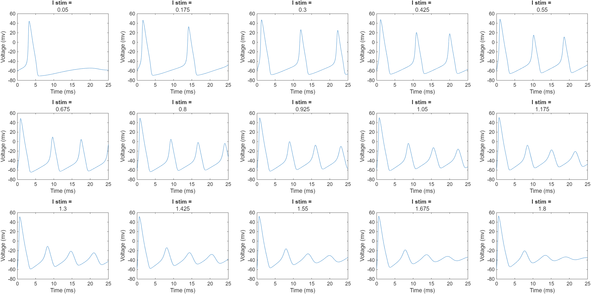
Figure 1. 15 voltage over time traces for repeated action potentials over a 25ms span with varying stimulus current values between 0.05 and 1.8 µA/cm².

Results from experiment two can be observed in Figure two. In experiment two, action potential morphology appeared consistent across pulse durations. At pulse durations 5 ms or longer, it appeared that cell membrane potential began to move toward threshold, but never fully initiated a subsequent action potential. Based on these visuals, there was no discernable difference between pulse durations shorter than 4 ms in length. Accordingly, a pulse duration of 1 ms was selected for the “best” simulation as it was the shortest tested value that reliably produced a complete action potential and closely resembled the voltage trace presented by Siciliano (2012). An action potential trace using the fixed, “best” parameters can be seen in Figure 3.

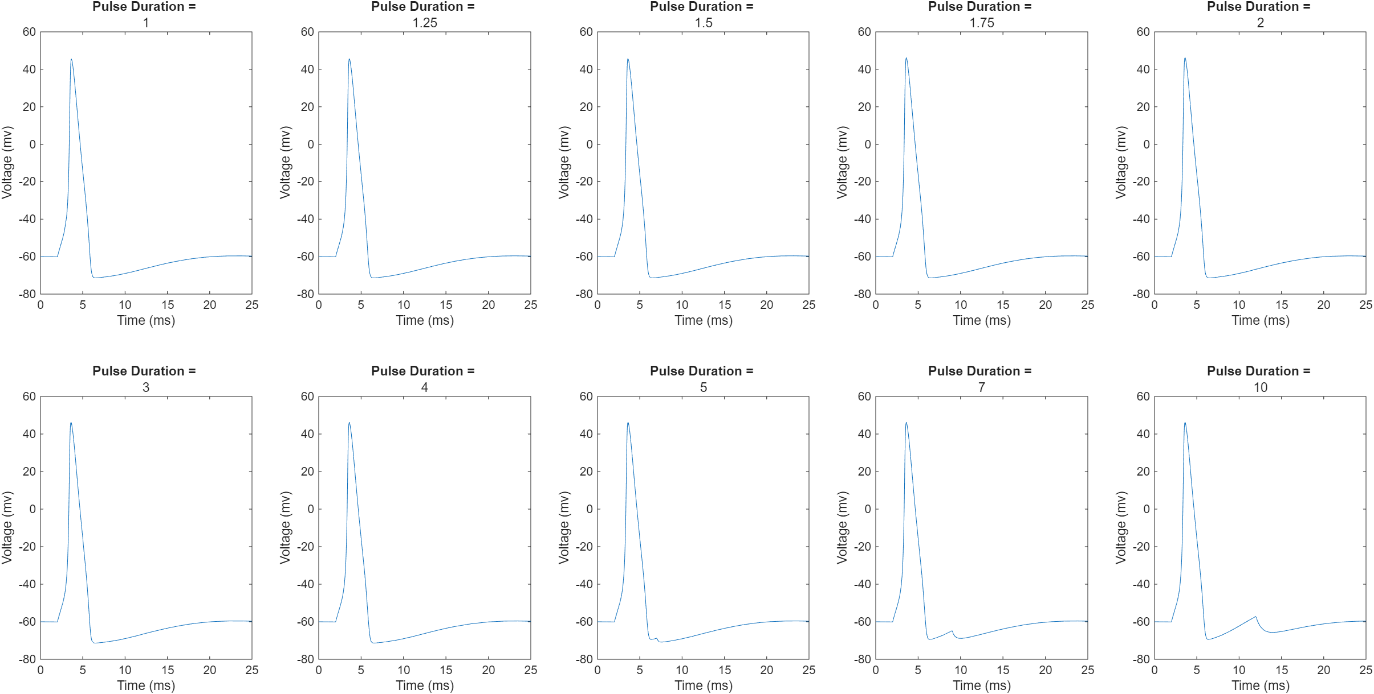Figure 2. 10 voltage over time traces for single action potentials at varying pulse durations with a fixed I_{stim} value of 0.175 µA/cm².
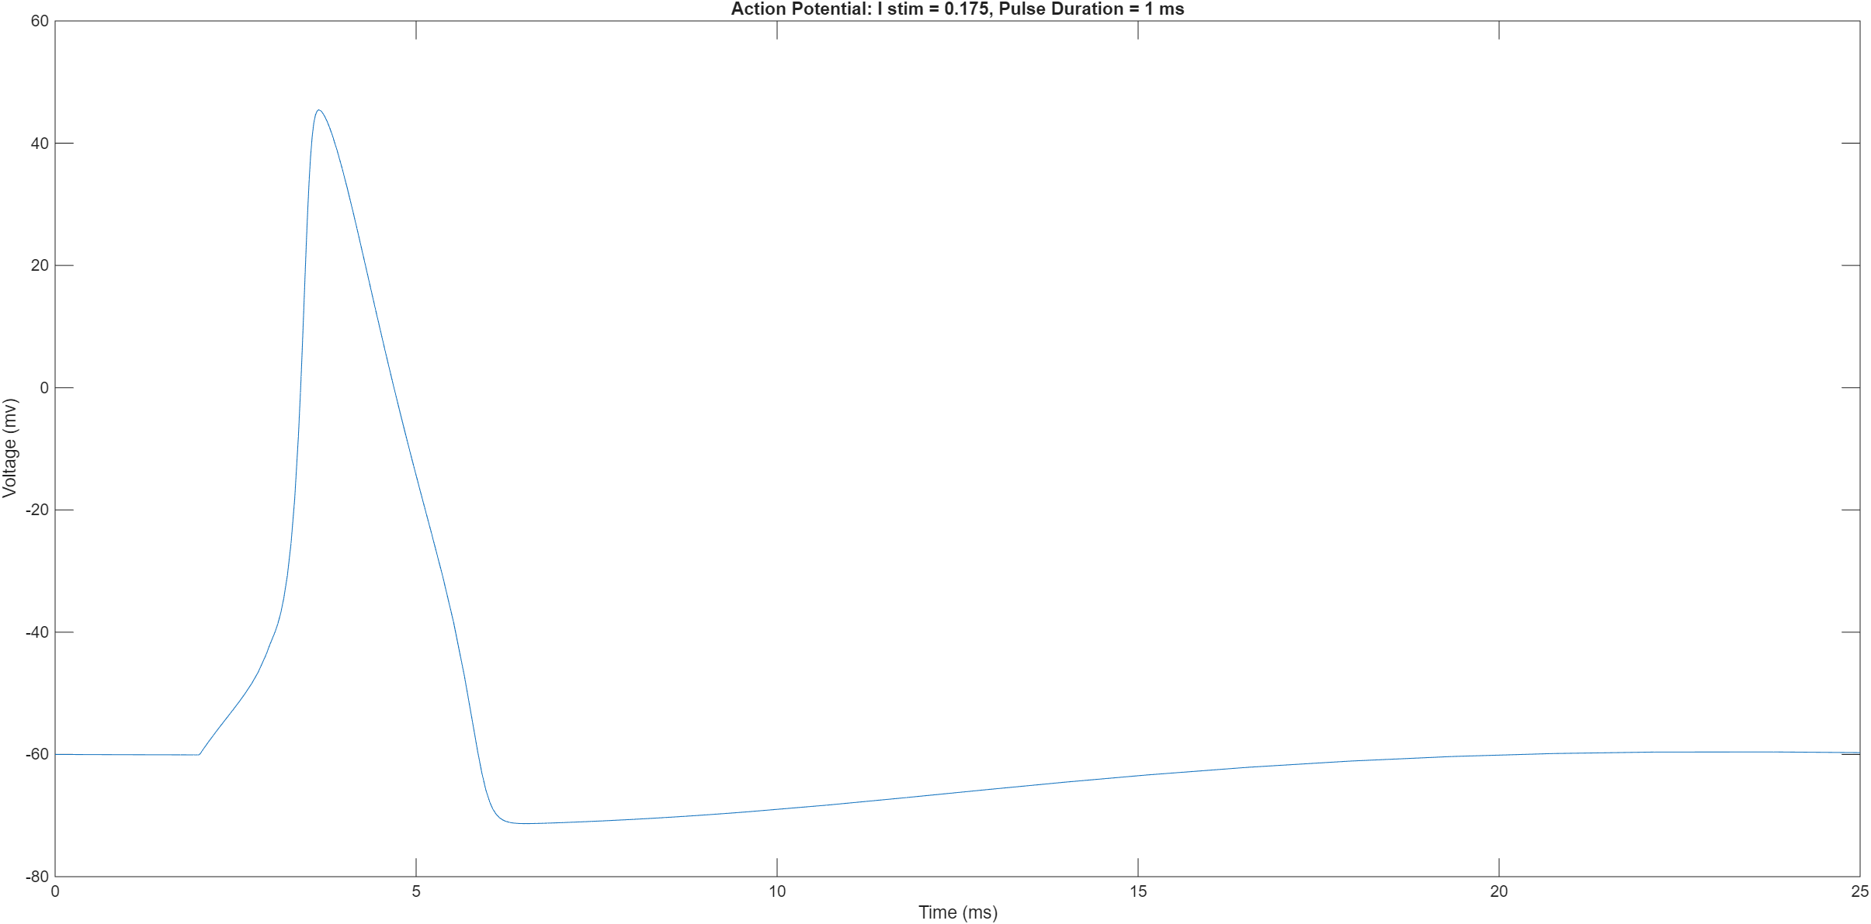
Figure 3. A single action potential using a stimulus current value of 0.175 µA/cm² and a pulse duration of 1 ms. This trace most closely resembled the one presented by Siciliano (2012).

References
Hodgkin, A. L., & Huxley, A. F. (1952). A quantitative description of membrane current and its application to conduction and excitation in nerve. The Journal of physiology, 117(4), 500–544. https://doi.org/10.1113/jphysiol.1952.sp004764
Siciliano, R. (2012). The Hodgkin-Huxley model: It’s extensions, analysis, and numerics.

